Abstract Factory Pattern
# Source: AI Source: Provided by: [Data Path: Persons Table -> ID Column: 1, Name_En Column: Motasem Essam] -> From: [ChatGPT] on [1/23/2026]
The Abstract Factory Pattern provides an interface to create families of related or dependent objects without specifying their concrete classes.
👉 Think of it like a furniture store: one factory creates modern chairs, sofas, and tables, while another creates victorian-style furniture.

🔑 Key Points
# Source: AI Source: Provided by: [Data Path: Persons Table -> ID Column: 1, Name_En Column: Motasem Essam] -> From: [ChatGPT] on [1/23/2026]
• Creates families of related objects
• Client code depends on abstract interfaces, not concrete classes
• Ensures consistency among products
• Useful when products must be used together

❌ Bad Example
# Source: AI Source: Provided by: [Data Path: Persons Table -> ID Column: 1, Name_En Column: Motasem Essam] -> From: [ChatGPT] on [1/23/2026]
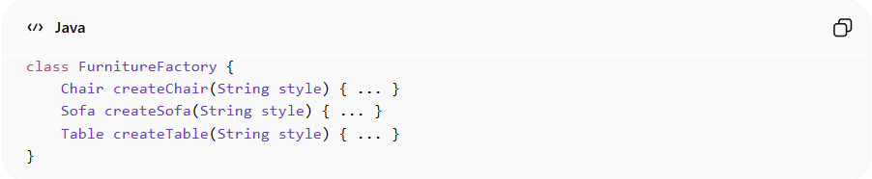
class FurnitureFactory {
Chair createChair(String style) { ... }
Sofa createSofa(String style) { ... }
Table createTable(String style) { ... }
}
Problems:
• Hard to add new product families
• Violates Open/Closed Principle
• Client code may still depend on concrete implementations

✅ Good Example
# Source: AI Source: Provided by: [Data Path: Persons Table -> ID Column: 1, Name_En Column: Motasem Essam] -> From: [ChatGPT] on [1/23/2026]
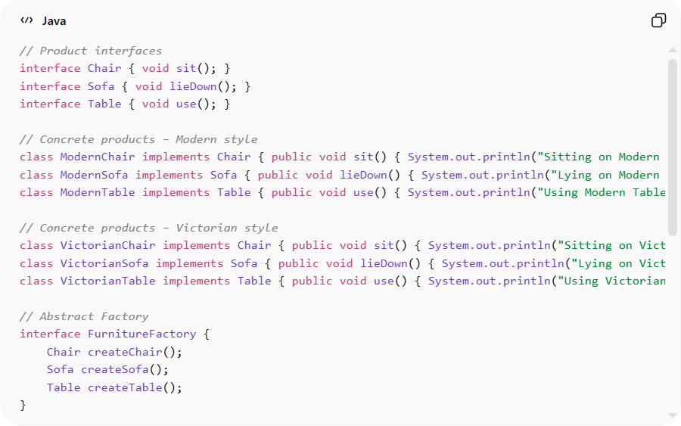
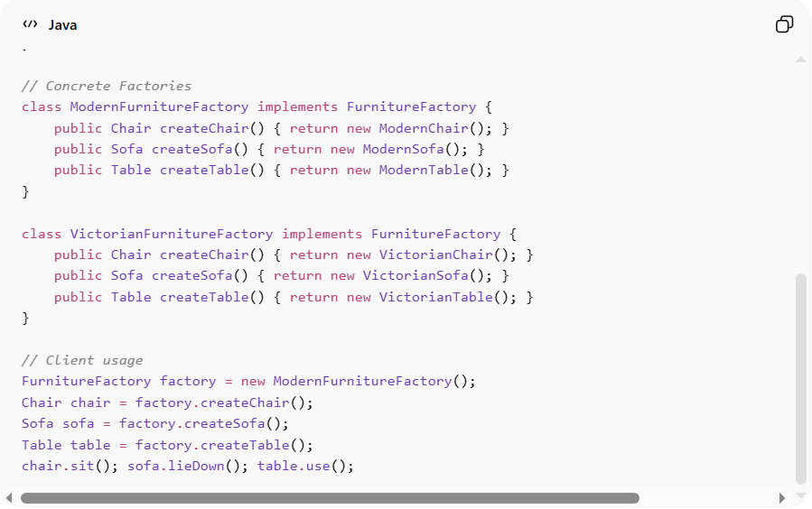
// Product interfaces
interface Chair { void sit(); }
interface Sofa { void lieDown(); }
interface Table { void use(); }

// Concrete products – Modern style
class ModernChair implements Chair { public void sit() { System.out.println("Sitting on Modern Chair"); } }
class ModernSofa implements Sofa { public void lieDown() { System.out.println("Lying on Modern Sofa"); } }
class ModernTable implements Table { public void use() { System.out.println("Using Modern Table"); } }

// Concrete products – Victorian style
class VictorianChair implements Chair { public void sit() { System.out.println("Sitting on Victorian Chair"); } }
class VictorianSofa implements Sofa { public void lieDown() { System.out.println("Lying on Victorian Sofa"); } }
class VictorianTable implements Table { public void use() { System.out.println("Using Victorian Table"); } }

// Abstract Factory
interface FurnitureFactory {
Chair createChair();
Sofa createSofa();
Table createTable();
}

// Concrete Factories
class ModernFurnitureFactory implements FurnitureFactory {
public Chair createChair() { return new ModernChair(); }
public Sofa createSofa() { return new ModernSofa(); }
public Table createTable() { return new ModernTable(); }
}

class VictorianFurnitureFactory implements FurnitureFactory {
public Chair createChair() { return new VictorianChair(); }
public Sofa createSofa() { return new VictorianSofa(); }
public Table createTable() { return new VictorianTable(); }
}

// Client usage
FurnitureFactory factory = new ModernFurnitureFactory();
Chair chair = factory.createChair();
Sofa sofa = factory.createSofa();
Table table = factory.createTable();
chair.sit(); sofa.lieDown(); table.use();
Benefits:
• Ensures consistent product families
• Client depends only on abstract interfaces
• Easy to switch families without modifying client code
• Supports scalable and maintainable design

⚡ Advantages
# Source: AI Source: Provided by: [Data Path: Persons Table -> ID Column: 1, Name_En Column: Motasem Essam] -> From: [ChatGPT] on [1/23/2026]
• Promotes consistency among related products
• Decouples client code from concrete classes
• Makes switching product families easy

⚠️ Disadvantages
# Source: AI Source: Provided by: [Data Path: Persons Table -> ID Column: 1, Name_En Column: Motasem Essam] -> From: [ChatGPT] on [1/23/2026]
• Can be overkill for small systems
• Adds extra layers of abstraction
• Harder to extend product types without modifying factories

🛠️ Use Cases
# Source: AI Source: Provided by: [Data Path: Persons Table -> ID Column: 1, Name_En Column: Motasem Essam] -> From: [ChatGPT] on [1/23/2026]
• Cross-platform GUI frameworks – Windows, Mac, Linux UI components
• Themeable applications – Dark/Light mode components
• Complex product families – Vehicles (cars, bikes, trucks) with multiple related parts
• Enterprise systems – Databases or services that need interchangeable implementations

